For information Paper no. 2/2006

Ethnic Minorities Forum
Meeting on 10 January 2006

Multilingual Phrasebook for Emergencies

Purpose
The paper briefs Members on the forthcoming pilot project for the production of a Multilingual Phrasebook for Emergencies.

Background
2. On several occasions, the minority communities have expressed concern about communication problems that they sometimes experience when seeking treatment in Hong Kong’s medical facilities. We share those concerns and have formulated proposals for addressing them, taking the view that the first priority should be to address medical emergencies. To that end, we plan to produce a phrasebook that will enable basic communication between first contact medical staff and patients in emergency situations. The phrasebook will help medical staff to make an initial assessment while an interpreter is found to help out.

3. In the course of our research into ways of facilitating communication with non-speakers of Chinese or English, we discovered that the British Red Cross Society have produced an ‘Emergency Multilingual phrasebook’ with advice and funding from the Department of Health in the United Kingdom. The phrasebook covers over 60 of the most common medical questions and terms and has been tested by the British health services.

Implementation
4. The British Red Cross Society has agreed to our adapting some of the content for local use and we have done so on the basis of advice from the Department of Health and the Adventist Hospital. The phrasebook will be in A4 size, spiral bound and printed on durable paper. The Chinese and English language questions are printed on the front and back cover flaps respectively, the flaps being designed so that each question will appear alongside the corresponding question in the language concerned: see Annex A. Communication can be effected when patients point to the appropriate question in the selected language and the medical attendants refer to the corresponding question in Chinese or English as printed on the cover clips.

5. The phrasebook will cover 65 key questions in a total of 18 languages: see the list at Annex B, which has been endorsed by the Department of Health. We will distribute it to public and private clinics, first aiders, selected non-governmental organisations and other medical professionals. Like the Red Cross phrasebook on which it is modelled, the Hong Kong version necessarily assumes that patients are literate in their own languages. However, with a view to helping non-literate patients as far as practically possible, the back cover will carry the national flags of the countries from which the 18 languages originate. We envisage patients simply pointing to the flag in question and staff then contacting an appropriate interpreter.

6. We are now in the final stages of translating the list of questions - which is more extensive than the Red Cross version – with a view to publication in early February 2006. We will explore the possibility of developing and expanding the phrasebook for non-emergency situations on the basis of feedback from medical practitioners on their experience with using it.

Action required
- Members are invited to note the contents of this paper.

Home Affairs Bureau
Race Relations Unit
January 2006

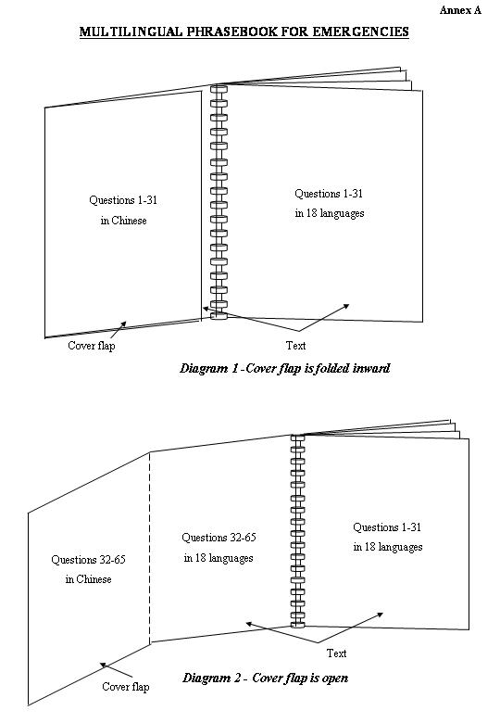

ENGLISH
Personal Data
1 What is your name? Can you write it in English?
2 Please write your address.
3 How old are you?
4 Can you give us the name and telephone number or address of someone to be contacted? Do you want us to contact your family or friend?
Medical History
5 Do you have any follow up cards / medical identification cards with you?
6 Have you been bitten by an animal recently? When? (show on calendar and clock)
7 Have you had an accident? When? (show on calendar and clock)
8 Have you ever had an operation / surgery? Point where.
9 When did your last menstrual period begin? (show on calendar) Are you pregnant? How many months pregnant are you? Could you possibly be pregnant? Can we do a pregnancy test?
10 Do you smoke? How many cigarettes a day?
11 Do you have 1.diabetes? 2.epilepsy? 3.asthma? 4.tuberculosis? 5.any other infectious diseases?
12 Have you ever had 1.heart problems? 2.angina? 3.high blood pressure? 4.heart attack? 5.stroke? 6.jaundice? 7.hepatitis?
13 Are you allergic to any medicine? Penicillin? Aspirin? Any other medicine?
14 Are you taking any medicine now? Have you some with you? Are you taking any other drugs or natural remedies?
15 How many tablets have you taken?
16 Are you up to date with tetanus immunisation? Did you have tetanus vaccine before? When was the last one? (show on calendar)
Present Symptoms
17 You will be examined soon by a 1.doctor. 2.nurse.
18 Did you lose consciousness? Are you dizzy?
19 When did you become ill? (show on calendar and clock) Do you have a fever?
20 Have you any pain? Point where. When did it start? (show on calendar and clock)
21 What is your level of pain? 1 (not in pain) 2 3 4 5 6 7 8 9 10 (chronic pain)
22 The pain, is it constant? Or does it come and go? What makes the pain worse? Breathing? Exertion?
23 Have you any bleeding? Point where.
24 Do you have a cough? Do you cough anything up? What colour? White? Yellow-green? Red? Brown?
25 Are you short of breath?
26 Have you vomited? Have you vomited blood?
27 Have you any diarrhoea?
28 Are you constipated?
29 Have you passed black stools?
30 Do your ankles swell?
31 Have you lost weight?
ENGLISH
32 Have you difficulty 1.seeing? 2.hearing? 3.swallowing? 4.walking?
33 Do you feel any foetal movement? Do you have any abnormal vaginal discharge? I need to listen to the foetal heart sound.
Others
34 Yes. No. Don’t know. I don’t understand.
35 Have you been to a country or other places outside Hong Kong recently? Which one? When?
36 I am a: 1.nurse. 2.doctor. 3.first aider. 4.paramedic. 5.social worker. 6.dentist.
37 May I examine you? Do you mind being examined by 1.a man? 2.a woman?
38 Sorry, this might hurt.
39 I need to take your blood pressure.
40 I need to listen to your chest.
41 I need to test your heart.
42 I need to examine you 1.internally. 2.abdomen.
43 I need to give you an injection.
44 I need to pass this tube.
45 I need to take a sample of your blood for testing.
46 I need to send you for an X-ray.
47 I need to give you some stitches. You need to go to your 1.doctor 2.nurse to get your stitches out on this day (show on calendar and clock).
48 You have a broken/fractured: 1.leg. 2.ankle. 3.arm. 4.wrist. 5.shoulder. 6.jaw.
49 You need to have a cast put on your: 1.leg. 2.ankle. 3.arm. 4.wrist.
50 You need to keep this (point to object) on until this date (show on calendar).
51 Please pass water into this container.
52 Do not eat or drink anything.
53 You may get up now.
54 You need to stay in hospital. Please wait until there is a bed available on the ward.
55 Everything will be all right. Don’t worry.
56 Shall I call a taxi for you?
57 Use this (point to object) if you need help.
58 Please wait. Please come this way. You may go home now.
59 Please come back if you have more problems.
60 Let me repeat that back to you…
Questions from patients
61 How long will I be waiting? Up to 1 hour, Up to 2 hours, Up to 3 hours, Up to 4 hours.
62 Will someone call my name?
63 Where is the public telephone, I need to ring my family / friend?
64 Please call a taxi for me to go home?
65 Am I going to be alright?

18 languages include Arabic, Bahasa Indonesia, Bengali, Chinese, Chinese (Simplified), English, French, Gujarati, Hindi, Japanese, Korean, Neplai, Portuguese, Punjabi, Sinhalese, Spanish, Tagalog, Tamil, Thai, Urdu and Vietnamese

